

**MALAD KANDIVALI EDUCATION SOCIETY’S**

**NAGINDAS KHANDWALA COLLEGE OF COMMERCE, ARTS & MANAGEMENT STUDIES & SHANTABEN NAGINDAS KHANDWALA COLLEGE OF SCIENCE**

**MALAD [W], MUMBAI – 64**

AUTONOMOUS INSTITUTION

(Affiliated To University Of Mumbai)

Reaccredited ‘A’ Grade by NAAC | ISO 9001:2015 Certified

**CERTIFICATE**

Name:Ms .**ADITI RAJESH PATEKAR**

Roll No: **330** Programme: BSc IT Semester: III

This is certified to be a bonafide record of practical works done by the above student in the college laboratory for the course **Data Structures (Course Code: 2032UISPR)** for the partial fulfilment of Third Semester of BSc IT during the academic year 2020-21.

The journal work is the original study work that has been duly approved in the year 2020-21 by the undersigned.

|  |  |  |
| --- | --- | --- |
| _____________________  External Examiner |  | ____________________  Mr. Gangashankar Singh  (Subject-In-Charge) |
| Date of Examination: | (College Stamp) |  |

**Class: S.Y. B.Sc. IT Sem- III Roll No:-330**

**Subject: Data Structures**

INDEX

|  |  |  |  |
| --- | --- | --- | --- |
| **Sr No** | **Date** | **Topic** | **Sign** |
| 1 | 04/09/2020 | Implement the following for Array:   1. Write a program to store the elements in 1-D array and provide an option to perform the operations like searching, sorting, merging, reversing the elements. 2. Write a program to perform the Matrix addition, Multiplication and Transpose Operation. |  |
| 2 | 11/09/2020 | Implement Linked List. Include options for insertion, deletion and search of a number, reverse the list and concatenate two linked lists. |  |
| 3 | 18/09/2020 | Implement the following for Stack:   1. Perform Stack operations using Array implementation. b. 2. Implement Tower of Hanoi. 3. WAP to scan a polynomial using linked list and add two polynomials. 4. WAP to calculate factorial and to compute the factors of a given no.   (i) using recursion, (ii) using iteration |  |
| 4 | 25/09/2020 | Perform Queues operations using Circular Array implementation. |  |
| 5 | 01/10/2020 | Write a program to search an element from a list. Give user the option to perform Linear or Binary search. |  |
| 6 | 09/10/2020 | WAP to sort a list of elements. Give user the option to perform sorting using Insertion sort, Bubble sort or Selection sort. |  |
| 7 | 16/10/2020 | Implement the following for Hashing:   1. Write a program to implement the collision technique. 2. Write a program to implement the concept of linear probing. |  |
| 8 | 23/10/2020 | Write a program for inorder, postorder and preorder traversal of tree. |  |

Practical -1 (A)

AIM:

program to store the elements in 1-D array and provide an option to perform the operations like searching, sorting, merging, reversing the elements.

THEORY:

Sorting:

The process of arranging elements of a data structure in an order(ascending or descending) is called sorting.

Merging :The process of combining elements of two data structures is called merging

Searching:

searching Algorithms are designed to check for an element or retrieve an element from any data structure where it is stored. Based on the type of search operation, these algorithms are generally classified into two categories:

**Sequential Search**

**Interval Search**

Code:

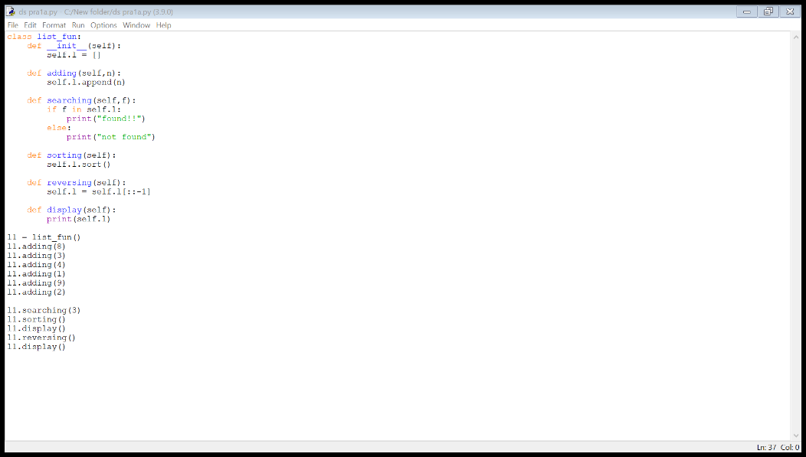

Output:

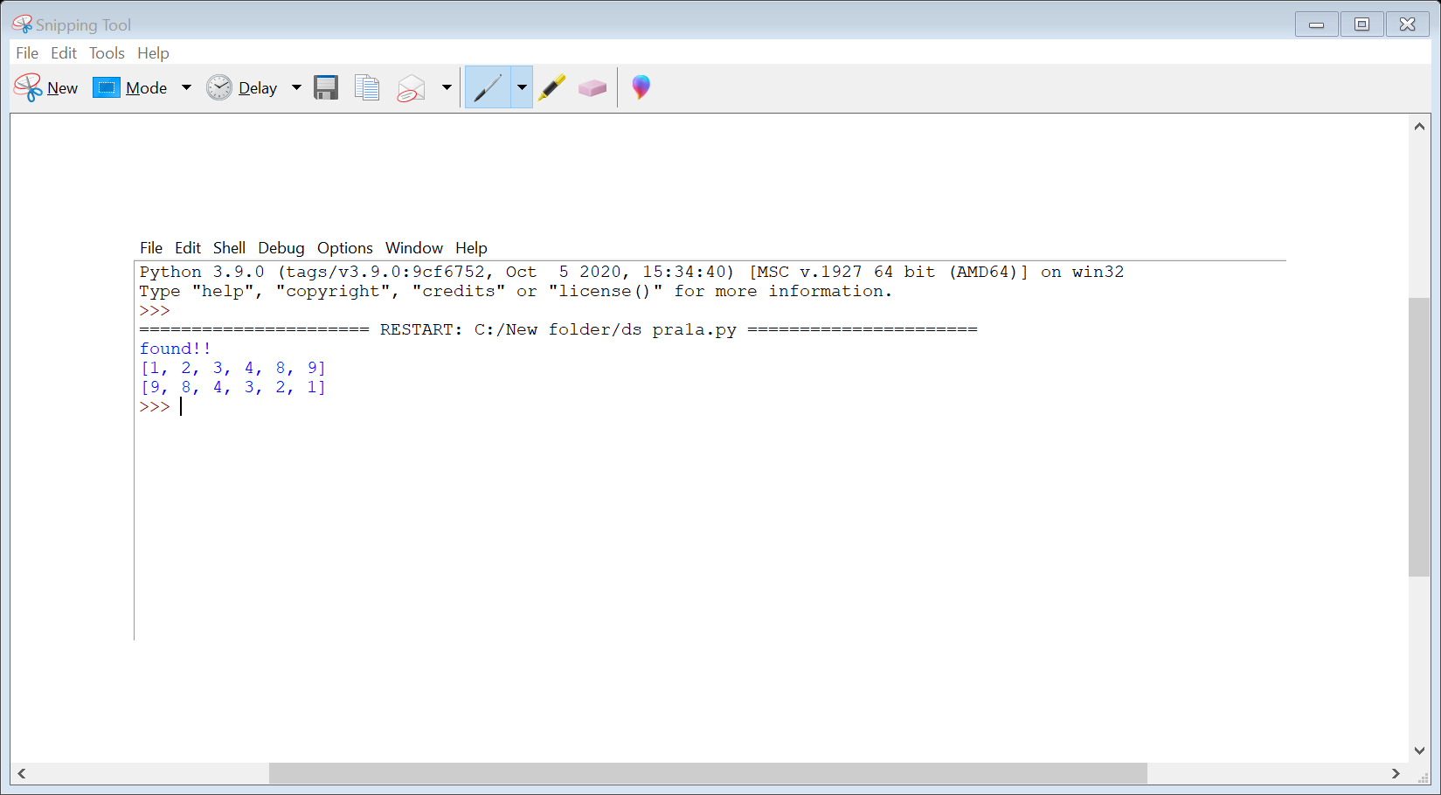

**Practical 1(B)**

AIM:

program to perform the Matrix addition, Multiplication and Transpose Operation.

THEORY:

add() − add elements of two matrices.

subtract() − subtract elements of two matrices.

divide() − divide elements of two matrices.

multiply() − multiply elements of two matrices.

dot() − It performs matrix multiplication, does not element wise multiplication.

sqrt() − square root of each element of matrix.

sum(x,axis) − add to all the elements in matrix. Second argument is optional, it is used when we want to compute the column sum if axis is 0 and row sum if axis is 1.

“T” − It performs transpose of the specified matrix.

CODE:

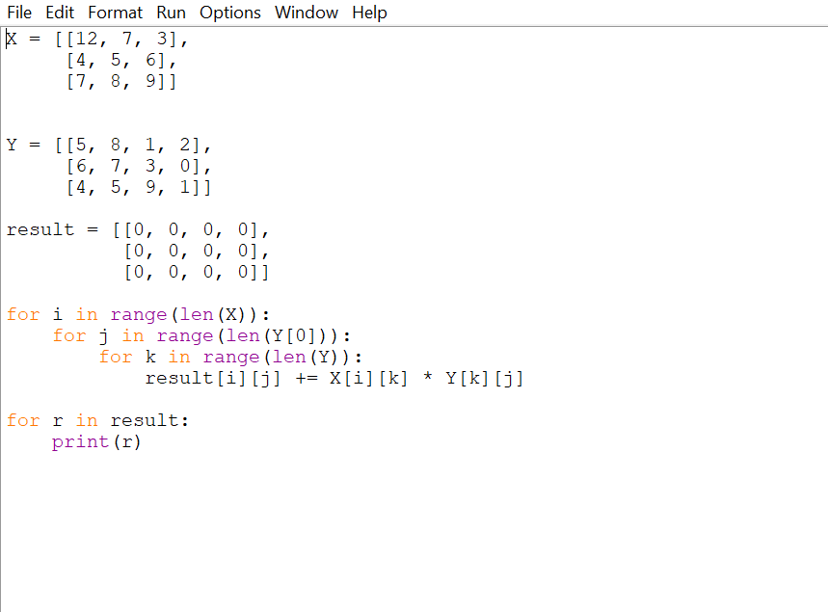

OUTPUT:

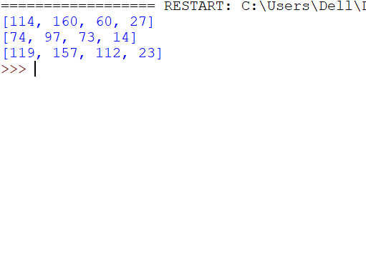

Practical 2

AIM:

Implement Linked List. Include options for insertion, deletion and search of a number, reverse the list and concatenate two linked lists

THEORY:

A linked list is a sequence of data elements, which are connected together via links. Each data element contains a connection to another data element in form of a pointer. Python does not have linked lists in its standard library. We implement the concept of linked lists using the concept of nodes as discussed in the previous chapter. We have already seen how we create a node class and how to traverse the elements of a node. In this chapter we are going to study the types of linked lists known as singly linked lists. In this type of data structure there is only one link between any two data elements. We create such a list and create additional methods to insert, update and remove elements from the list.

Insertion in a Linked List

Inserting element in the linked list involves reassigning the pointers from the existing nodes to the newly inserted node. Depending on whether the new data element is getting inserted at the beginning or at the middle or at the end of the linked list.

Deleting an Item form a Linked List

We can remove an existing node using the key for that node. In the below program we locate the previous node of the node which is to be deleted. Then point the next pointer of this node to the next node of the node to be deleted.

Searching in linked list

Searching is performed in order to find the location of a particular element in the list. Searching any element in the list needs traversing through the list and make the comparison of every element of the list with the specified element. If the element is matched with any of the list element then the location of the element is returned from the function.

Reversing a Linked List

To reverse a LinkedList recursively we need to divide the LinkedList into two parts: head and remaining. Head points to the first element initially. Remaining points to the next element from the head. We traverse theLinkedList recursively until the second last element.

Concatenating Linked Lists

Concatenate the two lists by traversing the first list until we reach it’s a tail node and then point the next of the tail node to the head node of the second list. Store this concatenated list in the first list.

CODE:

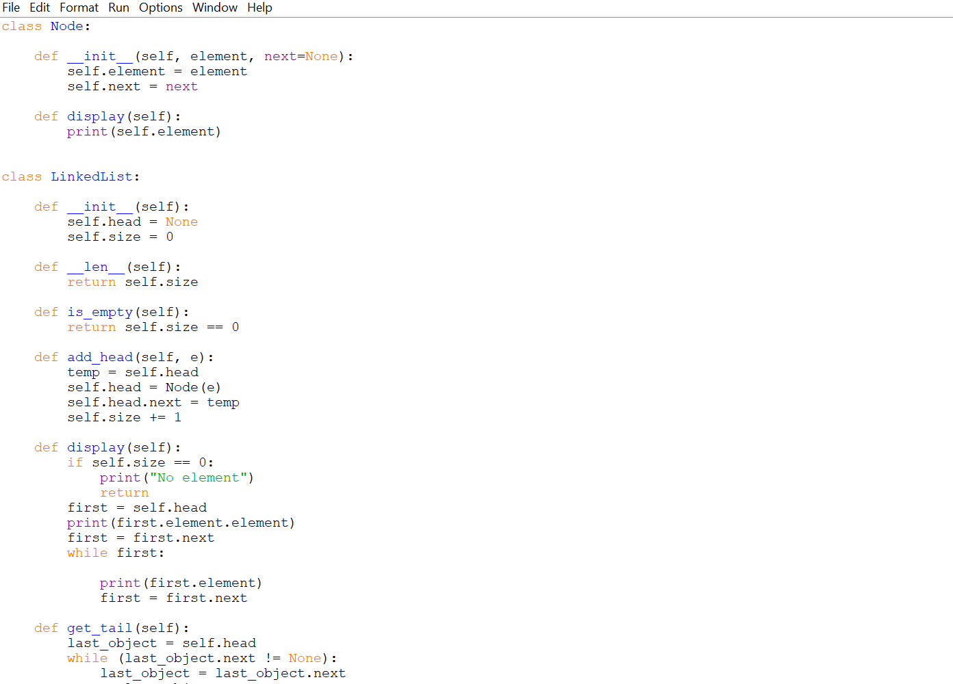

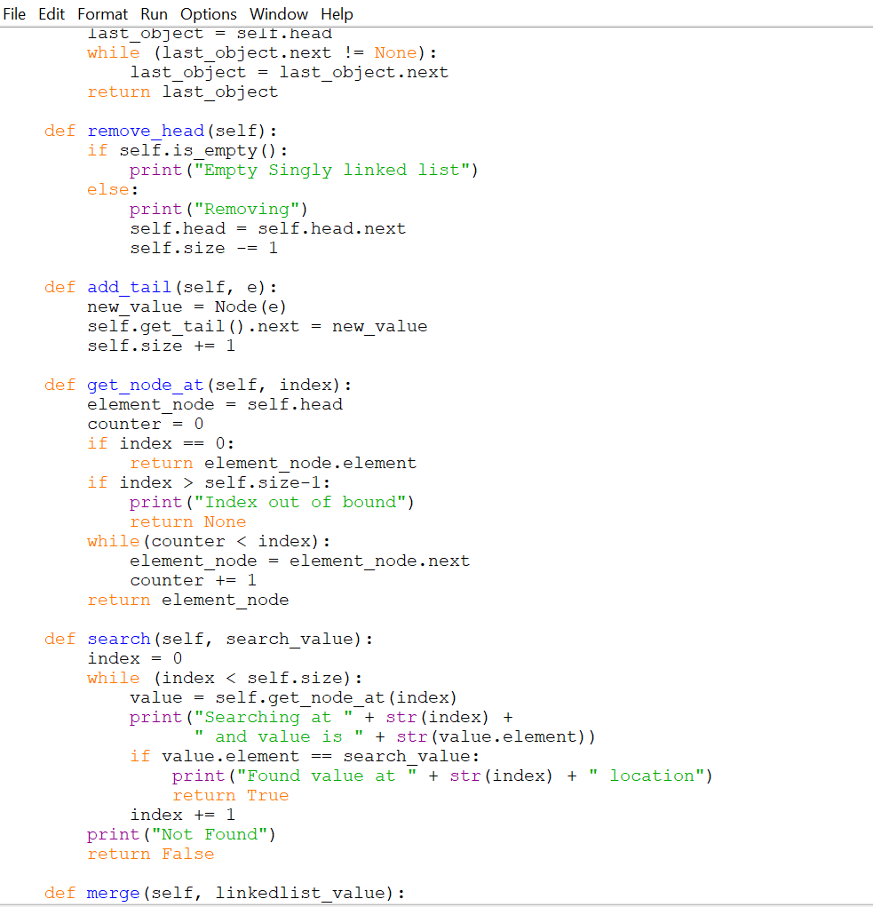

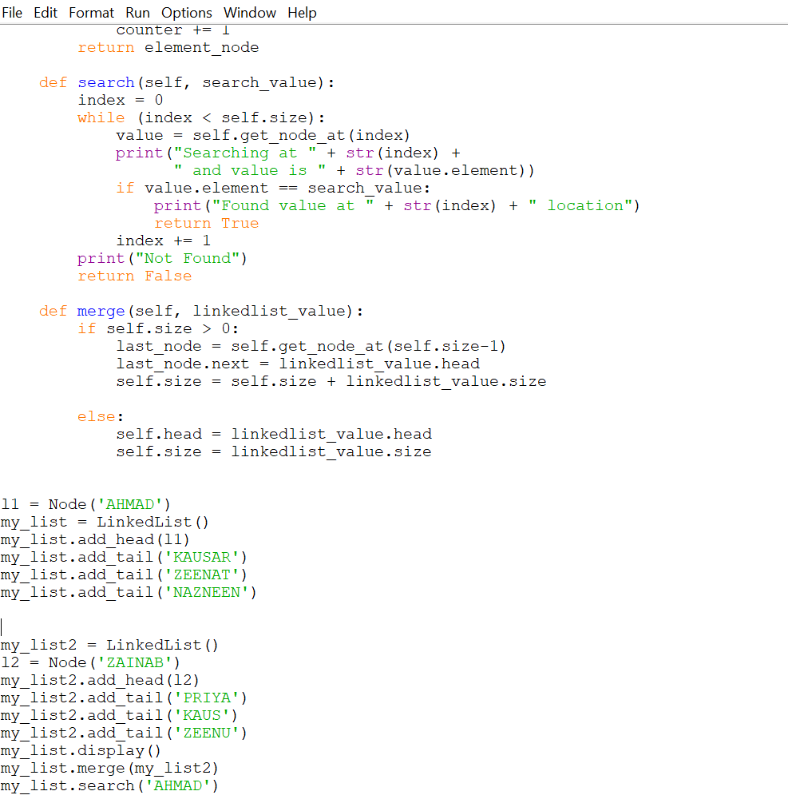

OUTPUT:

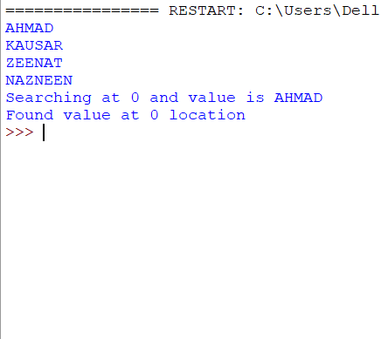

Practical 3(A)

AIM:

Perform Stack operations using Array implementation.

THEORY:

Stacks is one of the earliest data structures defined in computer science. In simple words, Stack is a linear collection of items. It is a collection of objectsthat supports fast last-in, first-out (LIFO) semantics for insertion and deletion. It is an array or list structure of function calls and parameters used in modern computer programming and CPU architecture. Similar to a stack of plates at a restaurant, elements in a stack are added or removed from the top of the stack, in a “last in, first out” order. Unlike lists or arrays, random access is not allowed for the objects contained in the stack.

There are two types of operations in Stack-

Push– To add data into the stack.

Pop– To remove data from the stack

CODE:

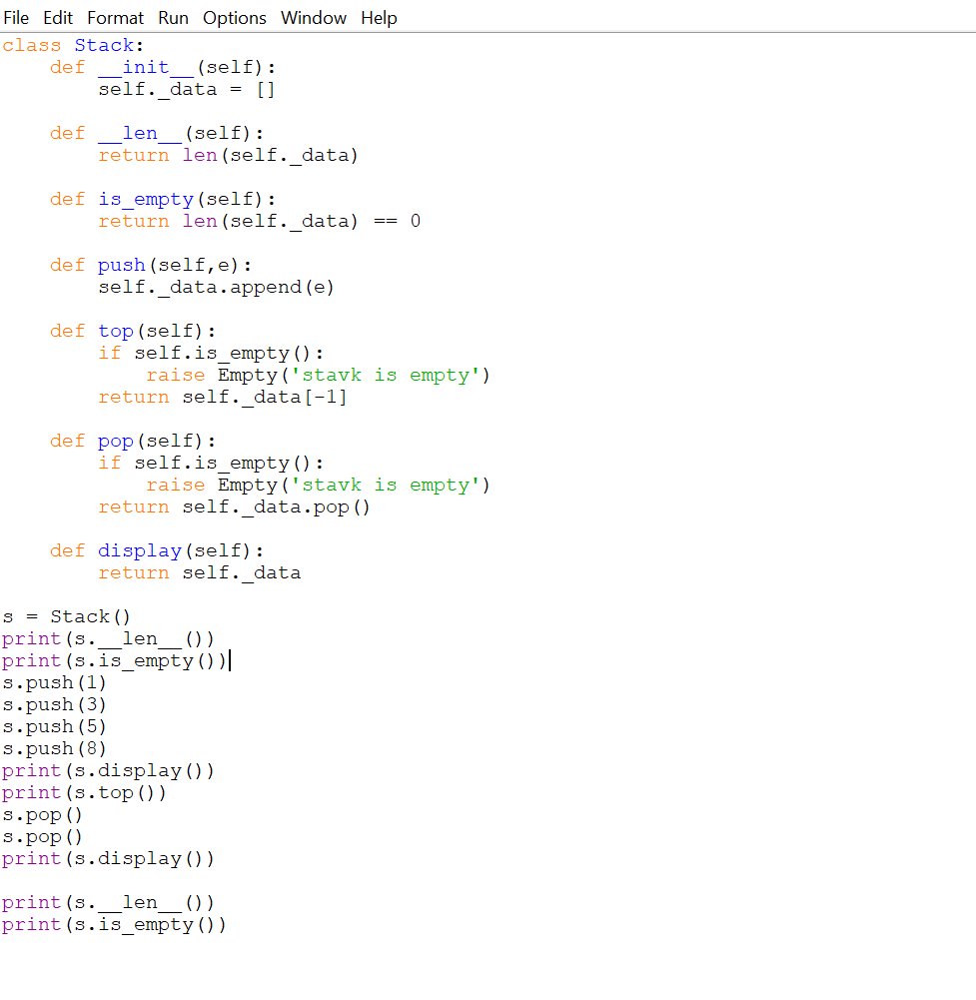

OUTPUT:

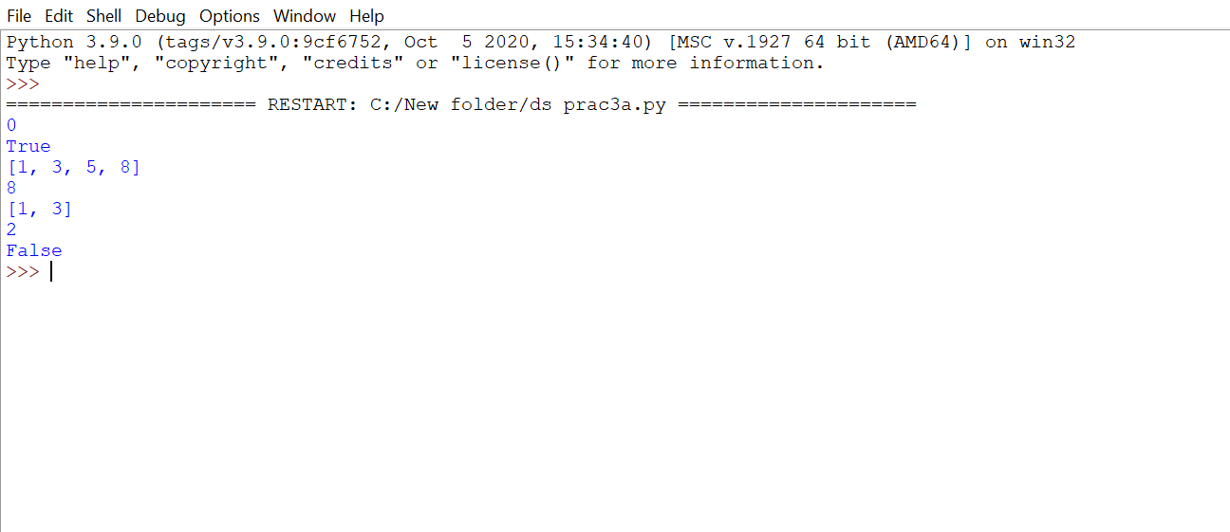

Practical 3(C)

AIM:

WAP to scan a polynomial using linked list and add two polynomial.

THEORY:

Polynomial is a mathematical expression that consists of variables and coefficients. for example x^2 - 4x +7In the Polynomial linked list, the coefficients and exponents of the polynomial are defined as the data node of the list.For adding two polynomials that are stored as a linked list. We need to add the coefficients of variables with the same power. In a linked list node contains 3 members, coefficient value link to the next node.

* a linked list that is used to store Polynomial looks like −

Polynomial : 4x7 + 12x2 + 45

CODE:

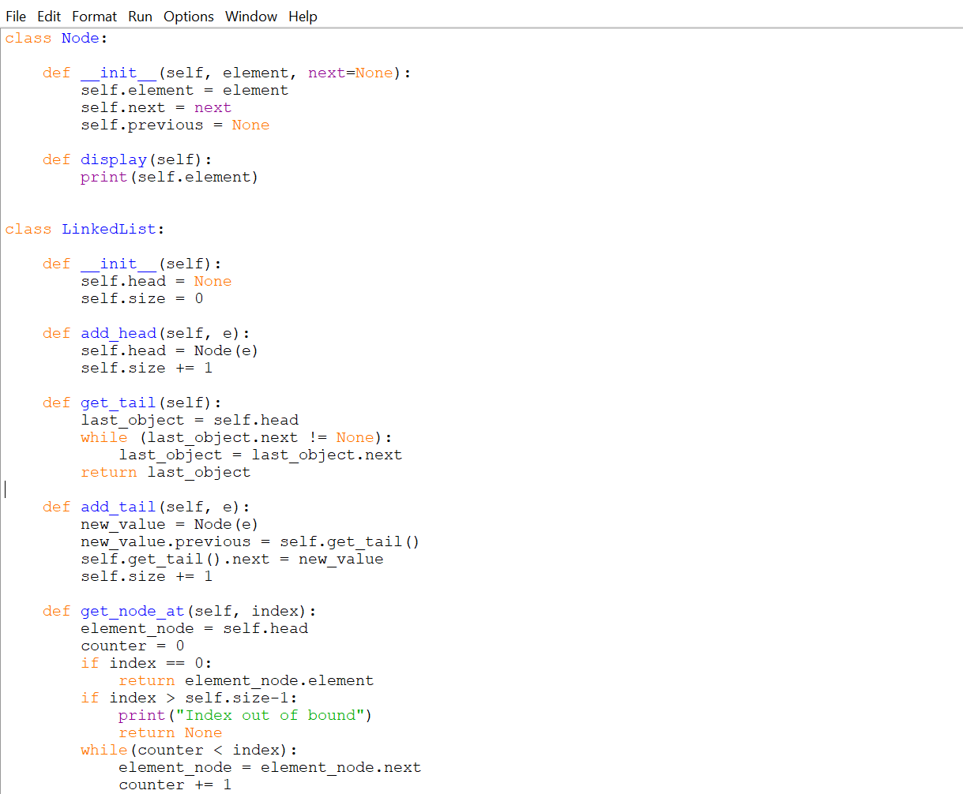

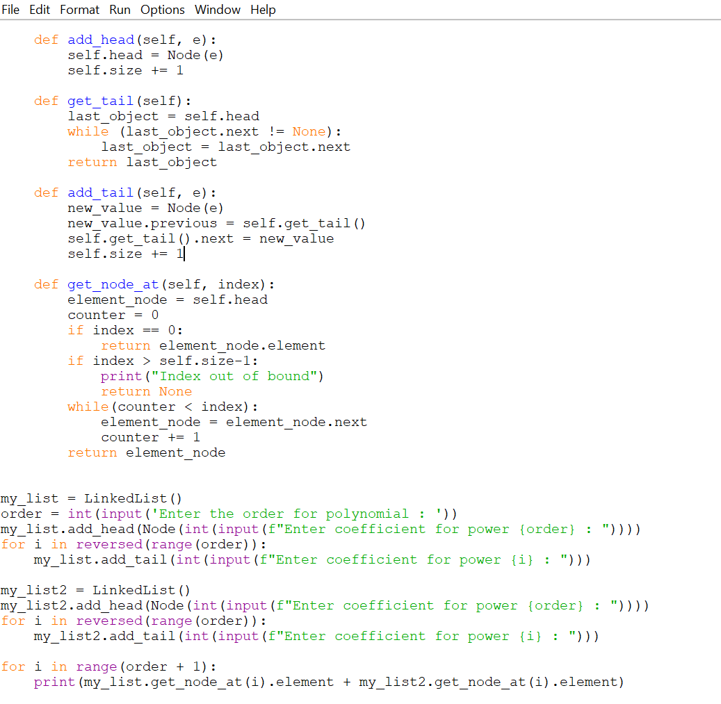

OUTPUT:

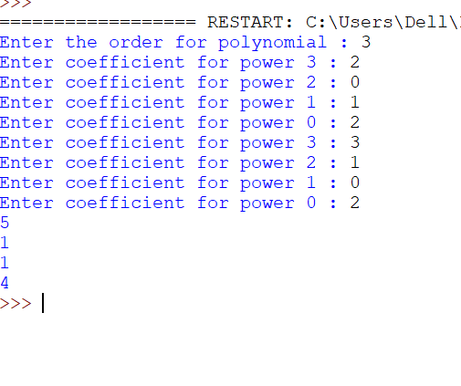

Practical 3(D)

AIM:

WAP to calculate factorial and to compute the factors of a given no. (i) using recursion, (ii) using iteration.

THEORY:

The factorial of a number is the product of all the integers from 1 to that number.

For example, the factorial of 6 is 1*2*3*4*5*6 = 720. Factorial is not defined for negative numbers and the factorial of zero is one, 0! = 1.

Recursion

In Python, we know that a function can call other functions. It is even possible for the function to call itself. These types of construct are termed as recursive functions.

Iteration

Repeating identical or similar tasks without making errors is something that computers do well and people do poorly. Repeated execution of a set of statements is called iteration. Because iteration is so common,Python provides several language features to make it easier.

CODE:

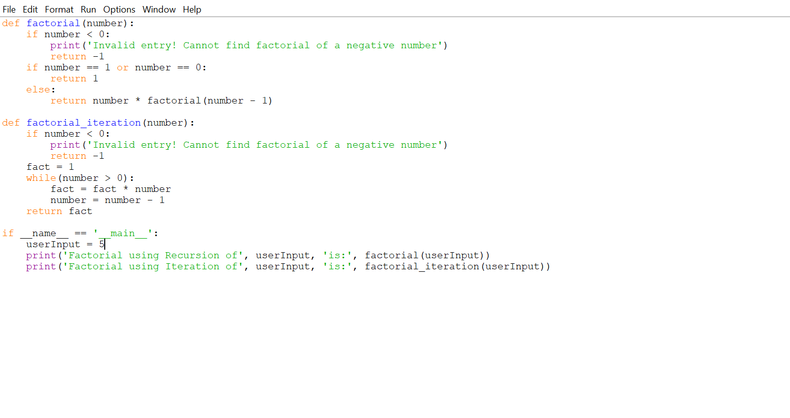

OUTPUT:

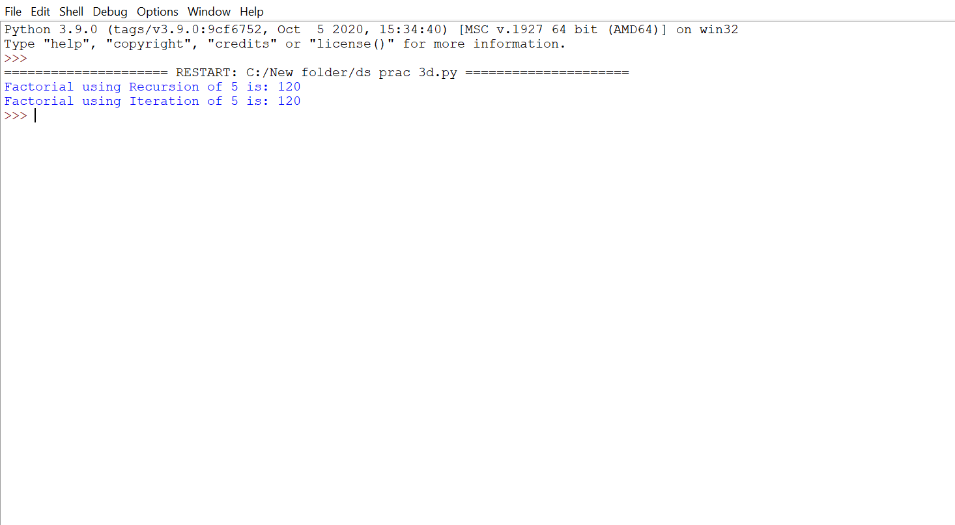

PRACTICAL 4

AIM:

Perform Queues operations using Circular Array implementation.

THEORY:

Circular queue avoids the wastage of space in a regular queue implementation using arrays. Circular Queue works by the process of circular increment i.e. when we try to increment the pointer and we reach the end of the queue, we start from the beginning of the queue.

Here, the circular increment is performed by modulo division with the queue size. That is,

if REAR + 1 == 5 (overflow!), REAR = (REAR + 1)%5 = 0 (start of queue)

The circular queue work as follows:

two pointers FRONT and REAR

FRONT track the first element of the queue

REAR track the last elements of the queue

initially, set value of FRONT and REARto -1

1.Enqueue Operation

check if the queue is full

for the first element, set value of FRONT to 0

circularly increase the REAR index by 1 (i.e. if the rear reaches the end, next it would be at the start of the queue)

add the new element in the position pointed to by REAR

2. Dequeue Operation

check if the queue is empty

return the value pointed by FRONT

circularly increase the FRONT

index by 1for the last element, reset the values of FRONT and REAR to -1

CODE:

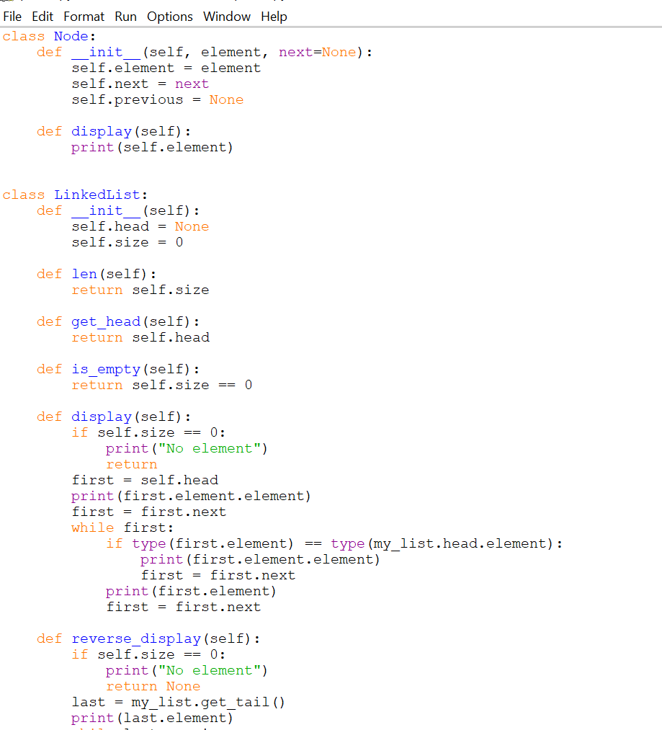

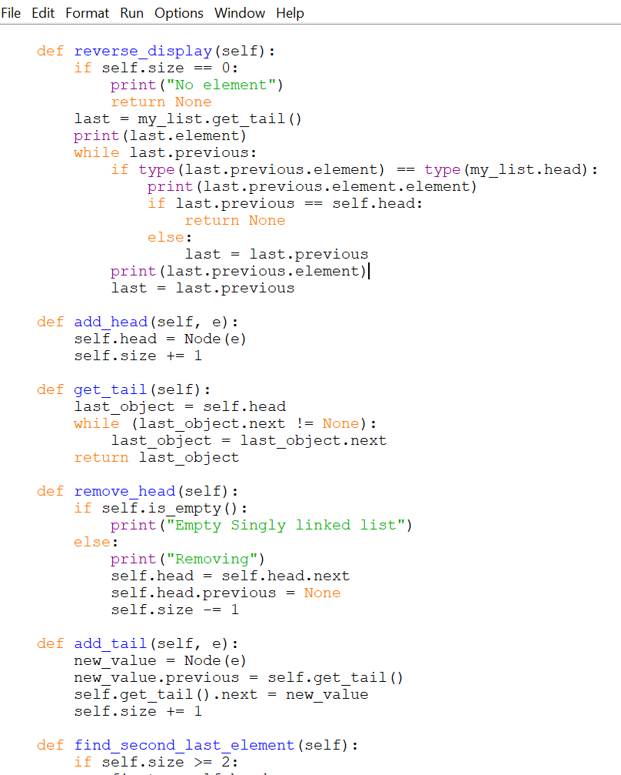

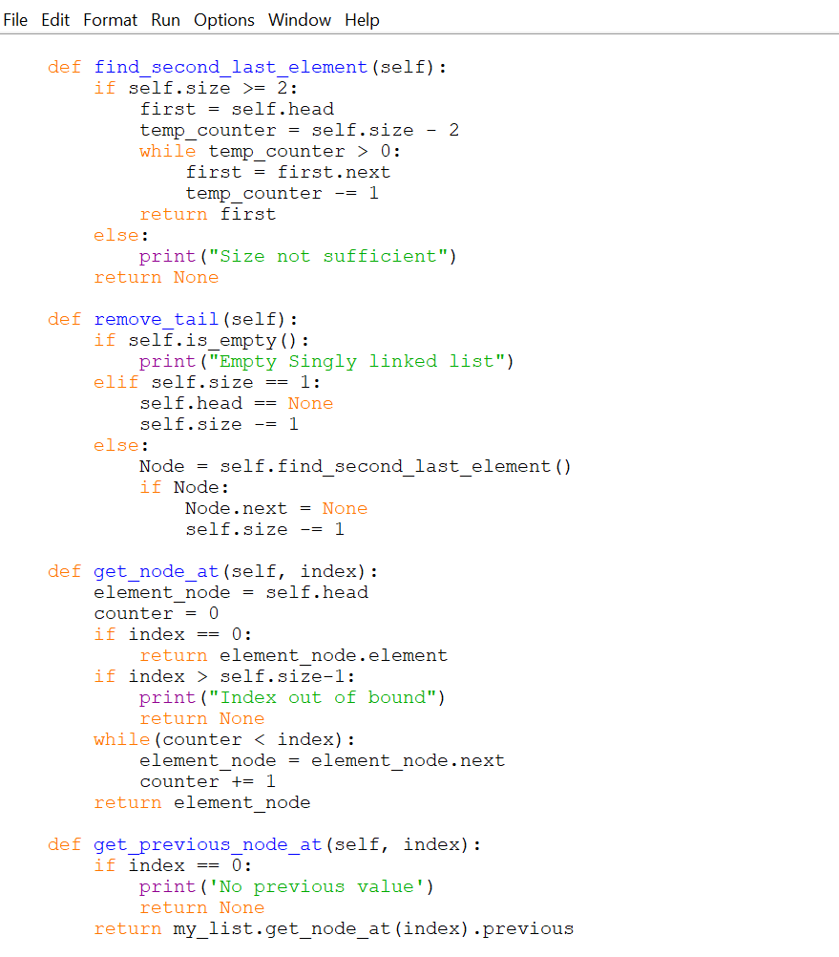

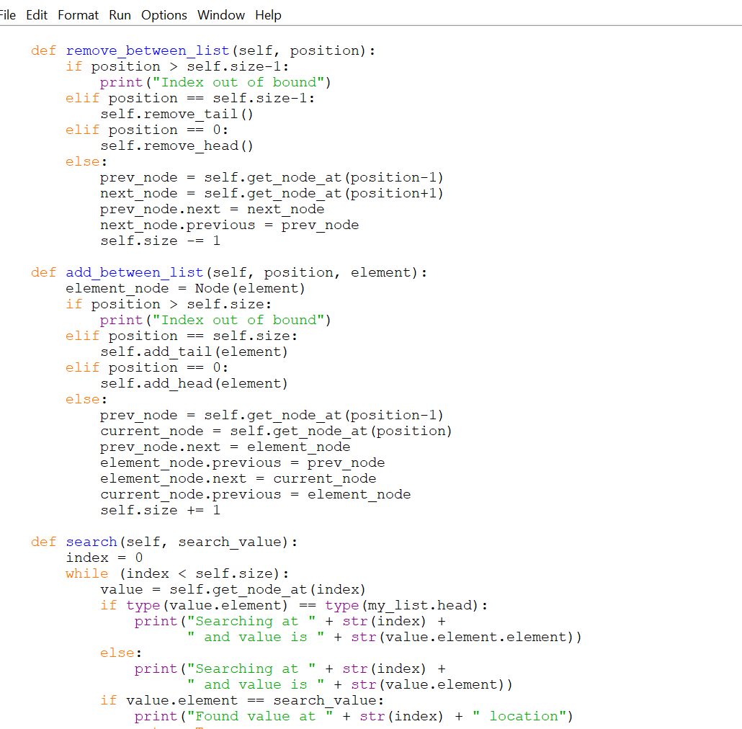

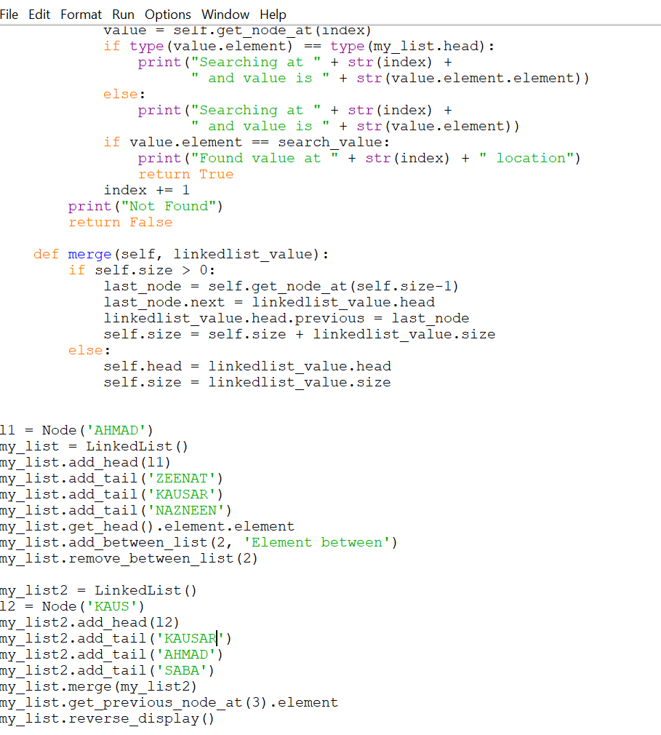

OUTPUT:

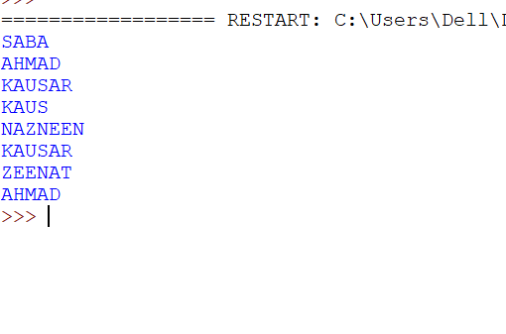

practical 5

AIM:

Write a program to search an element from a list. Give user the option to perform Linear or Binary search.

THEORY:

Linear Search:

This linear search is a basic search algorithm whichsearches all the elements in the list and finds the required value. ... This is also known as sequential search.

Binary Search:

In computer science, a binary searchor half-interval search algorithm finds the position of a target value within a sorted array. The binary searchalgorithm can be classified as a dichotomies divide-and-conquer search algorithm and executes in logarithmic time.

CODE:

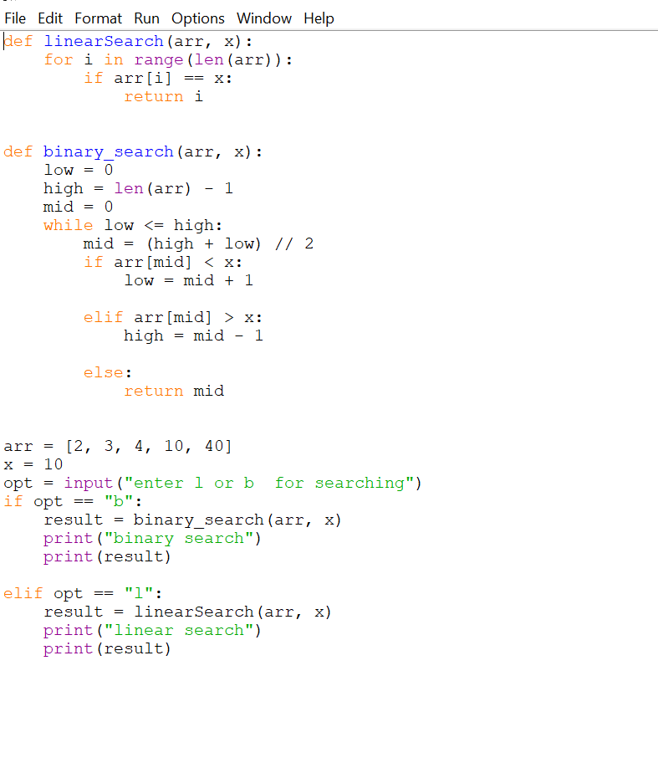

OUTPUT:

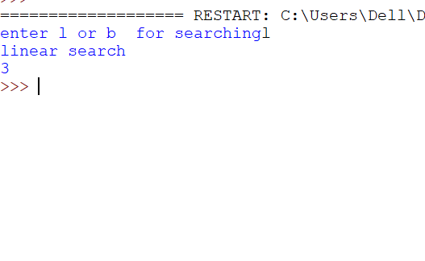

Practical 6

AIM:

WAP to sort a list of elements. Give user the option to perform sorting using Insertion sort, Bubble sort or Selection sort.

THEORY:

Bubble Sort:

Bubble Sort is the simplest sorting algorithm that works by repeatedly swapping the adjacent elements if they are in wrong order.

Selection Sort:

The selection sort algorithm sorts an array by repeatedly finding the minimum element (considering ascending order) from unsorted part and putting it at the beginning. The algorithm maintains two subarrays in a given array

Insertion Sort:

Insertion sort iterates, consuming one input element each repetition, and growing a sorted output list. At each iteration, insertion sort removes one element from the input data, finds the location it belongs within the sorted list, and inserts it there. It repeats until no input elements remain.

CODE:

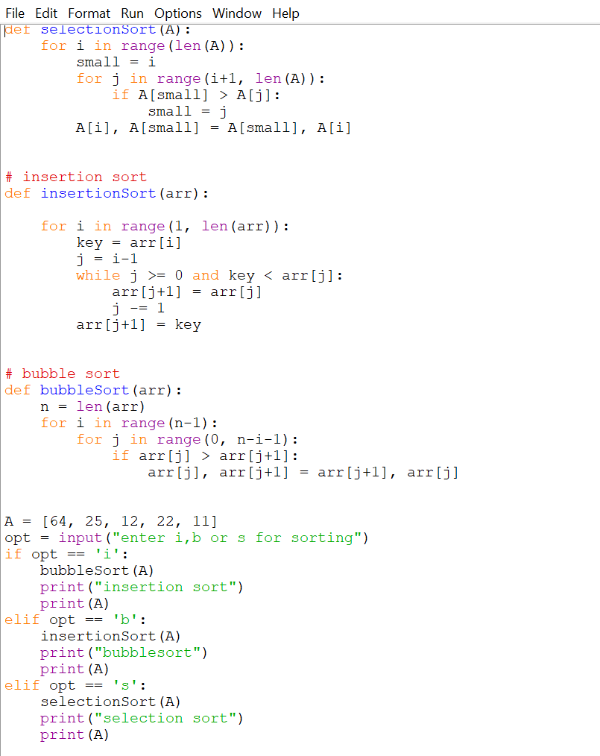

OUTPUT:

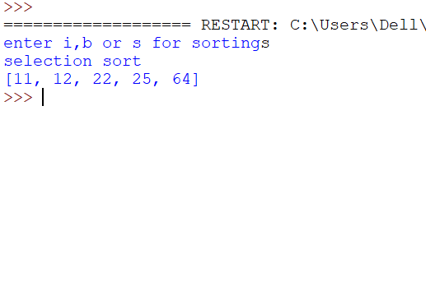

Practical 7(A)

AIM:

Write a program to implement the collision technique.

THEORY:

Hashing:

Hashing is an important Data Structure which is designed to use a specia

l function called the Hash function which is used to map a given value with a particular key for faster access of elements. The efficiency of mapping depends of the efficiency of the hash function used.

Collisions:

A Hash Collision Attack is an attempt to find two input strings of a hash function that produce the same hash result. If two separate inputs produce the same hash output, it is called a collision.

Collision Techniques:

Separate Chaining:

The idea is to make each cell of hash table point to a linked list of records that have same hash function value.

Open Addressing:

Like separate chaining, open addressing is a method for handling collisions. In Open Addressing, all elements are stored in the hash table itself. So at any point, the size of the table must be greater than or equal to the total number of keys (Note that we can increase table size by copying old data if needed).

CODE:

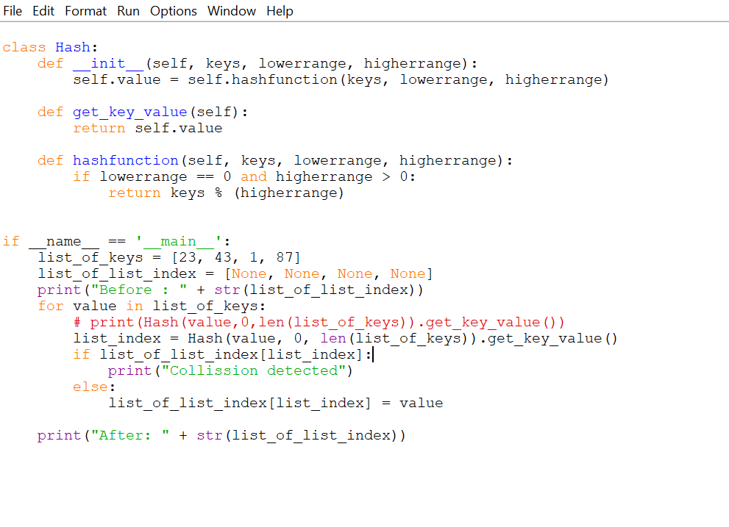

OUTPUT:

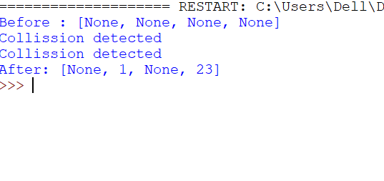

PRACTICAL 7(B)

AIM:

Write a program to implement the concept of linear probing.

CODE:

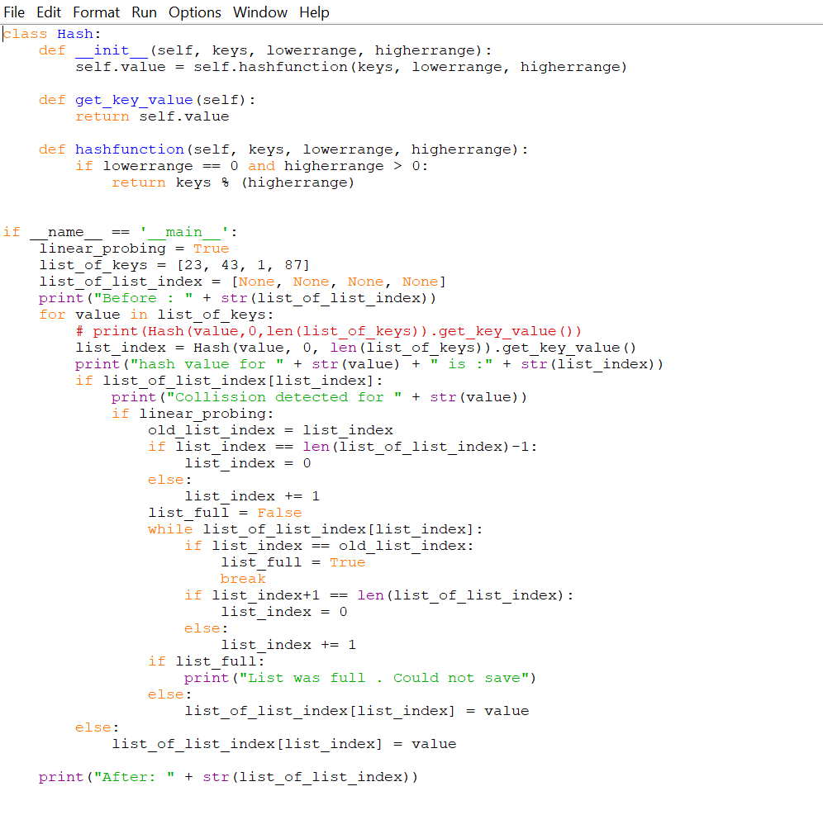

OUTPUT:

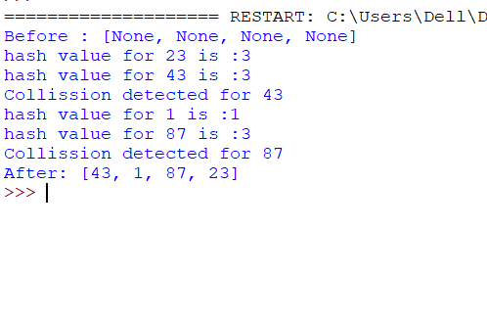

Practical 8

AIM:

Write a program for inorder, postorders and preorder traversal of tree.

THEORY:

Inorder:

In case of binary search trees (BST), Inorder traversal gives nodes in non-decreasing order. To get nodes of BST in non-increasing order, a variation of Inorder traversal where Inorder traversal s reversed can be used.

Preorder:

Preorder traversal is used to create a copy of the tree. Preorder traversal is also used to get prefix expression on of an expression tree.

Postorder:

Postorder traversal is also useful to get the postfix expression of an expression tree.

CODE:

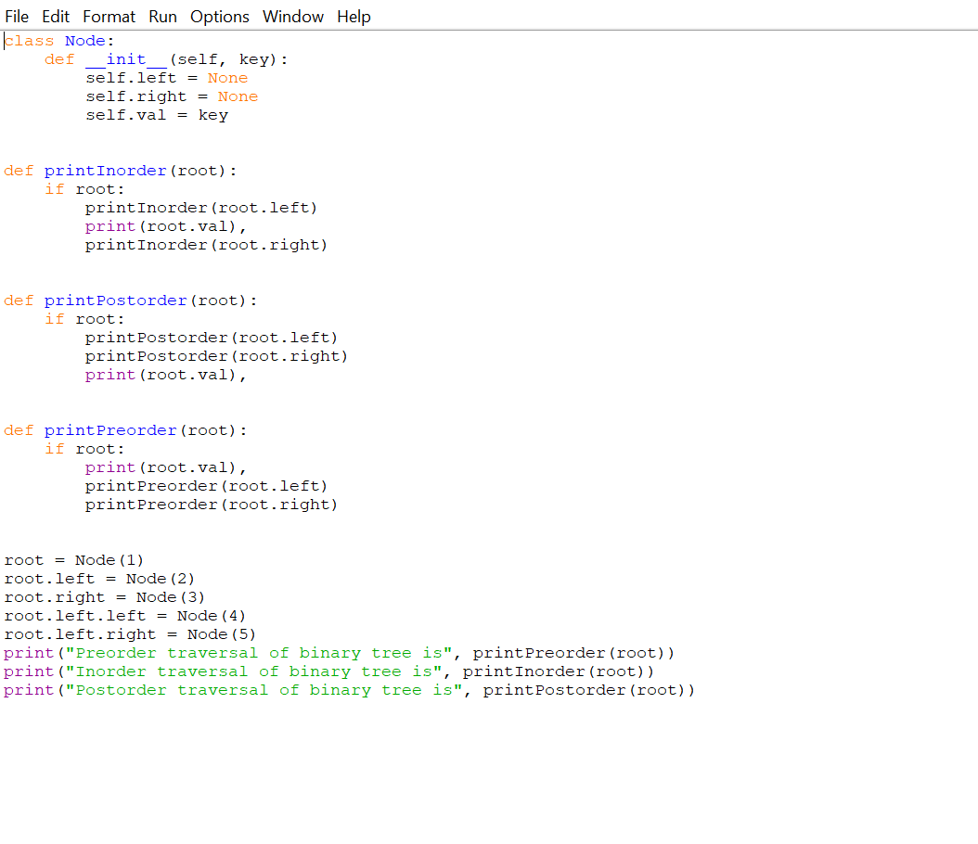

OUTPUT:

